|  |  |
| --- | --- |
| hpesm_pri_grn_pos_rgb | **PL Mtrls Shortage Maintenance Process** |

**Document number:**

**Revision History:**

|  |  |  |  |
| --- | --- | --- | --- |
| **Revision** | **Description of Change** | **Originator** | **Date** |
| A | As issued | Bella Yao | Sep 25, 2017 |
|  |  |  |  |

1. **PL Mtrls Shortage Website address:** <http://16.187.228.117/shortage/>
2. **PL Mtrls Shortage update cycle**

At least twice a day

Deadline: 11:30am & 17:30pm

1. **PL Mtrls Shortage interfaces**

|  |  |  |  |  |  |
| --- | --- | --- | --- | --- | --- |
| Interface | Edit Permission | Required Action | Listed by | Description | Data Source |
| Summary | N/A | Display only | PLO | All the published PL material shortages which had been received by WH | Buyer interface, WH interface |
| Planner | N/A | Display only | PLO | PL material shortage uploaded by HW last time; data will refresh when WH upload new raw file | Buyer interface, WH interface |
| Buyer | Buyer | Input supply schedule | P/N | Current PL material shortage; line item will be removed once WH input actual ETA | Raw files uploaded by WH |
| KWE | N/A | Display only | P/N | PL shortage materials which carrier is HPE-KWE and ETA is overdue, current date or current date+1 day | Buyer interface |
| WH | Warehouse | Input actual ETA | P/N | Current PL material shortage with ETA and Shipment info | Buyer interface |
| Importer | Warehouse | Upload raw files |  | Raw files |  |

* All interfaces are visible for all ordinary users
* Pls DO NOT edit anything if you have no permission accordingly, especially WH interface
* Buyer interface: Buyer input supply schedule for PL material shortages
* Update buyer list: For coordinate to maintain buyer info list
* WH interface: WH will foresee the coming supply, and input actual ETA

1. **PL Mtrls Shortage website update**
2. Open website: <http://16.187.228.117/shortage/>

Default interface is “Summary”

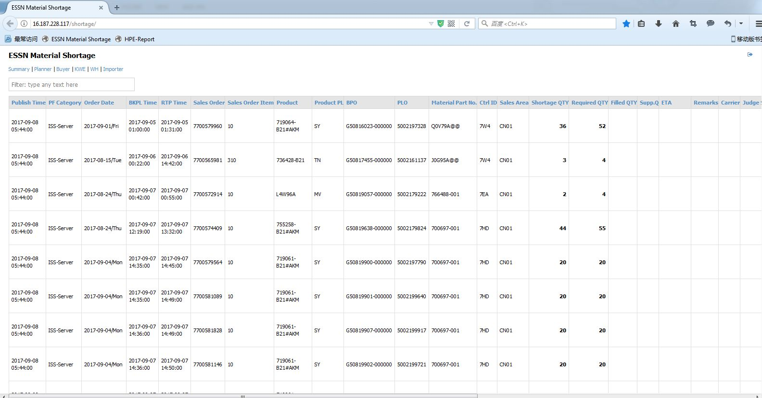

1. Go to “Buyer” interface. All current shortage material will be displayed.

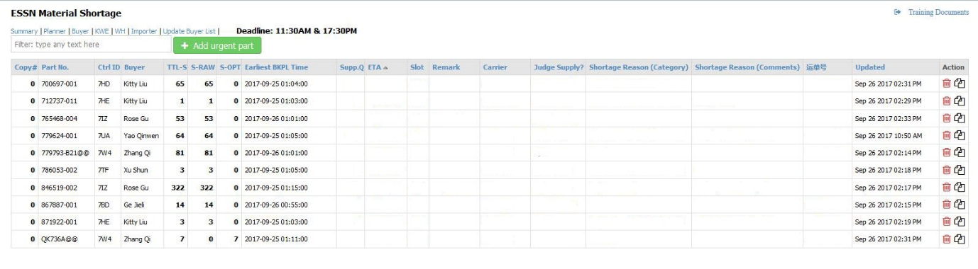

1. Filter buyer name, control ID, part No, or any other characters.

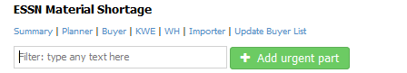

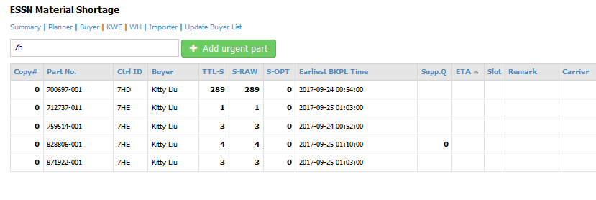

1. Input supply schedule information. Data will be automatically saved.
2. Copy line item — use this function when one shipment cannot cover the total shortage.

5-1. Click  to copy the selected line item

5-2. New record displayed, input Supp.Q, ETA, Slot and Carrier, input 运单号when Carrier=HPE-KWE



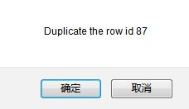 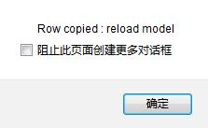

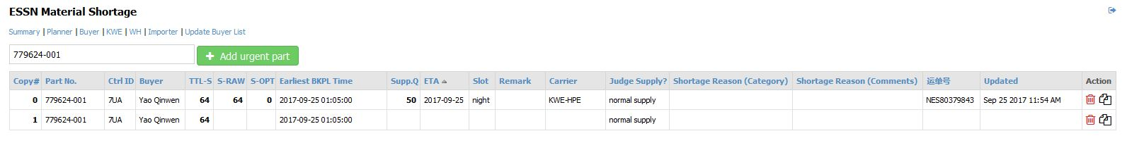

* Copy#: “0” means original shortage record uploaded by WH, “1” means the first copied line item, and “2” means the second copied line item and so on.
* Click  to delete selected line item. Pls delete copied line items by backwards. DO NOT delete the original shortage record Copy#0.

1. Add urgent part manually — use this function ONLY for raw part which will be used as shortage material after relabel, part change, etc.

6-1. Click 

6-2. Input P/N and apply

6-3. New record displayed, input Supp.Q, ETA, Slot and Carrier, input 运单号when Carrier=HPE-KWE

6-4. Manually added part will be removed from “Buyer” once WH input actual ETA but will not show in “Summary” for summary or analysis

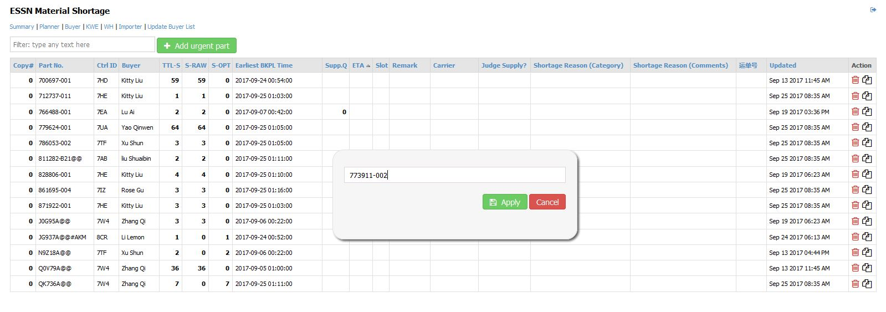

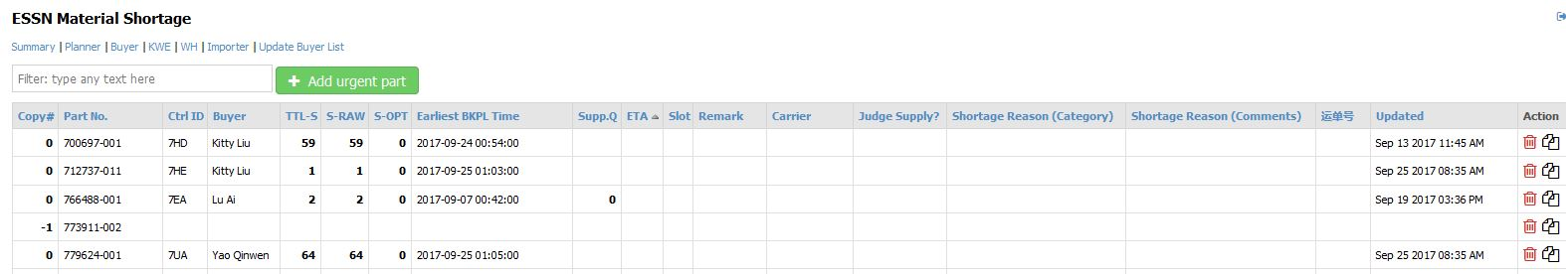

* Warehouse upload PL shortage list from time to time, at least twice a day.
* Buyer update supply schedule at least twice a day. Deadline: 11:30am, 17:30pm
* Before accomplish of automatic email sending function, warehouse will manually send out shortage list via Email.
* PL Shortage list sent by WH will not totally same as it on website. Please refer to the updated one on website.

1. **PL Mtrls Shortage format update guideline**
2. **Refer to below excel file for detail explanations.**

****

1. **Notes:**

2-1. Mandatory item for all shortage parts: Supp.Q, ETA, Slot and Carrier

Even for part change, rework or relabel parts, etc.

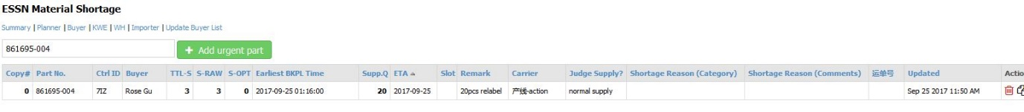

2-2. When “Carrier”= “HPE-KWE” >> input HAWB

HAWB要求不含破折号，但是否需要统一大小写？

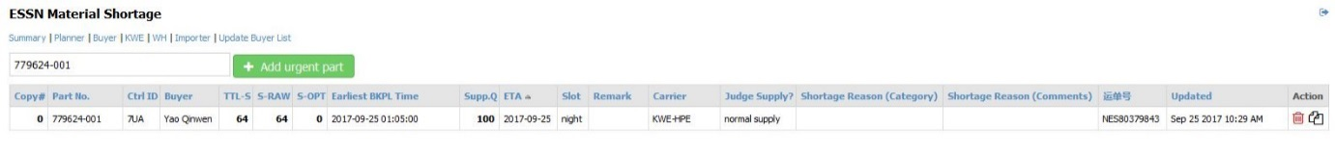

2-3. When “Judge Supply?”= “input reason” >> Select shortage reason category from drop down list

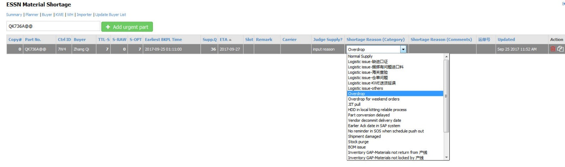

1. **Training Document download**

Click “Training Document” in top right corner to download the training documents.

****

1. **PL Mtrls Shortage update flow chart**

